BIODATA
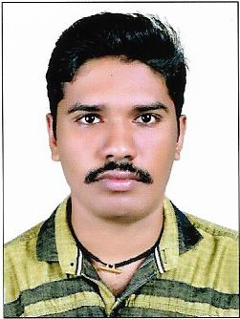
A.S.AKHIL
Kattumadathil House
Peringilipuram P O
Ennakkad Alappuzha
Pincode:689624
Email:akhilas6086119@gmail.com
Contact No:9947465966
Career Objective:
To work with an organization where I could utilize my knowledge and skills for mutual
growth of company and me
Educational Qualifications:
- SSLC – ARN School, Jorhat – 72% - 2007
- Plus Two – GHS School, Budhanoor – 76.3% - 2009
- BCA – SB College, Changanaserry – IGNOU University – 65% – 2011-2014
- MCA – IIIT , Kottayam – IGNOU University - 64.34% - 2016
- Java training - Evosoft Technologies – 6 month -Ernakulam
Computer Skills:
- Programming Language: C, C++, J2EE,SQL.
- Operating Systems: Windows XP, Windows 7, Windows 8.
- Web Designing Language: HTML, XML, DHTML, CSS, Javascript, Jquery.
- Tools: Notepad, Notepad++, Word, Excel, PowerPoint.
Achievements and Internship
- Participated in seminars.
- Certificate from G-Tec Computer Education for Computer Operation and C++ Programming.
- Certificate from KELTRON for Hardware Familiarization Program.
Academic Project: BCA
- Project: “Voyage Management System”
- Description: Online ticket booking for train, ship, plane and vehicles (bus and car) including cargo transfer
- Language used: Java
- Software used: NetBeans
- Database: Wamp Server
- Institution: Istrox, Kottayam
Academic Project: MCA
- Project: “Construction Management System”
- Description: Online management of construction of buildings and partial works i.e., Online management of builder, constructor, client and Employee)
- Language used: ASP.NET 4.0 with C#
- Software used: Microsoft Visual Studio 2010
- Database: Microsoft SQL Server-2010
- Institution: IIIT, Kottayam
Personal Profile:
- Date of Birth: 27/08/1991
- Gender: Male
- Languages Known: English, Hindi and Malayalam
- Father’s Name: K C Suresh
- Mother’s Name: PremeelaSuresh
Referees:
Ashamol Vasu (HOD)
SB College, Changanaserry
Contact No: 9961288461

Liya Maria Mathew
SB College Changanaserry
Contact No: 9605251104

Declaration:
I hereby declare that the information provided is true and correct to the best of my knowledge and belief

Date: yours faithfully,
Place:Peringilipuram A S Akhil

